Cost Benefit Analysis of Requiring Limited Photovoltaic and Electric Vehicle Charging Infrastructure in New Construction

[This proposal provides a scope of work and budget for code research proposed by John Hall at the July 23, 2018 Electrical/Fire TAC and July 25, 2018 Structural TAC teleconference meetings.]

PI: Jeffrey Sonne
Co-PI: Richard Raustad
Co-PI: Donard Metzger
Florida Solar Energy Center
July 27, 2018

Research Questions
The purpose of this research project is to investigate the costs and benefits of requiring installation of limited infrastructure in new Florida construction to facilitate the later addition of solar photovoltaic (PV) systems and electric vehicle (EV) charging systems:

- Solar photovoltaic system installations are increasing in Florida but the rate of installation is inhibited by the cost of these systems. The suggested research is to answer the following questions.
  - What is the average installed cost of solar photovoltaic systems on one- and two family homes in Florida?

  - What would be the additional cost for a one- or two-family home to provide infrastructure to facilitate the future installation of a solar PV system
i. Said infrastructure to consist of the following:
- Structural blocking in the roof for mounting of the PV panels and equipment.
- A trade size 1 empty, capped raceway from the PV array location to an interconnection point at the electrical service.
- A NEMA 3R enclosure, capable of being sealed by the electrical utility, on the supply side of the main electrical service disconnect for interconnection of the PV system. The enclosure to be labeled “For Future Solar PV System.”

  - What would be the amount of reduction in the cost of an installed PV system charged by a solar contractor as a result of this pre-installed infrastructure? What would be the net reduction/increase in cost of a solar PV system to the homeowner as a result of installation of the contemplated infrastructure?

  - How many additional solar PV systems would likely be installed as a result of this pre-installed infrastructure?

- Electric vehicle sales are increasing in Florida. These vehicles require the ability to recharge the batteries. The suggested research is intended to answer the following questions.

- What is the average cost of installing an electric vehicle charging system in a one- or two-family home or townhouse with an attached garage?

- What is the average cost of installing an electric vehicle charging system in a new multi-family garage or parking area when during construction vs. post construction?

- What is the average cost of installing an electric vehicle charging system in new commercial buildings with garage parking during construction vs. post construction?

- What would be the additional cost to provide infrastructure to facilitate future of electric vehicle charging systems? For example, for one- or two-family homes or townhouses the infrastructure may consist of the following:
    - Provision in the main electrical panel or a properly rated subpanel of an empty space for a two-pole breaker, with sufficient capacity for a 240 volt, 40 ampere branch circuit.

    - Installation of a trade size 1 empty raceway from the electrical panel to the location of an electric vehicle charging system, terminating in an empty enclosure with a blank cover. The enclosure to be labeled “For Future EV Charging System.”

- What would be the amount of reduction in the cost of installing an electric vehicle charging system as a result of this pre-installed infrastructure?

Background and Code Relevance to Florida
Florida is seeing a significant increase in solar PV installations. In a 2016 Miami Herald article, a Duke Energy Florida representative reported over 100 residential and business customers are installing solar per month, and a 400 percent increase in installations over the past five years. The Florida Public Service Commission recently reported a 51% increase in customer-owned renewable generation in Florida between 2016 and 2017, with PV continuing to be the most popular renewable choice. Florida is also starting to see a number of all-solar communities.

Electric vehicle sales are also increasing as shown in Figure 1.
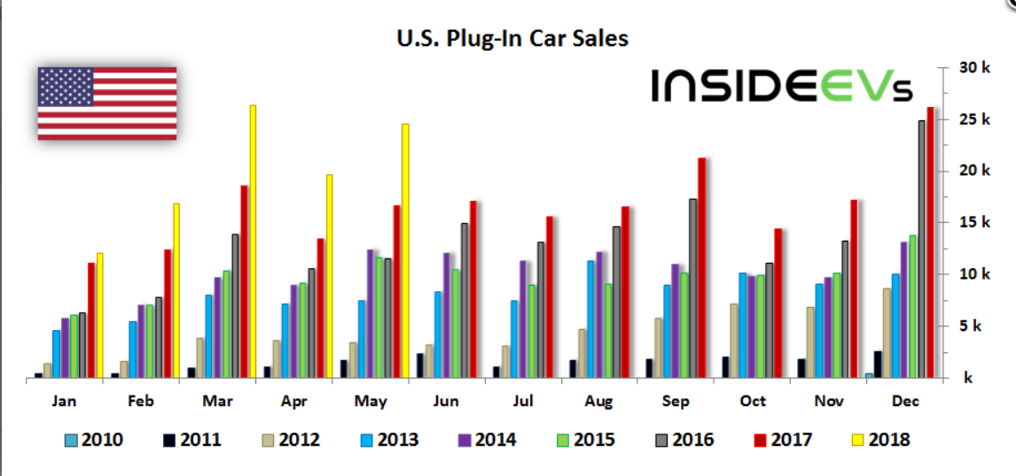
Figure 1. U.S Plug in Car Sales by Month and Year –from https://insideevs.com/monthly-plug-in-sales-scorecard/ July 25,2018
The proposed research will help inform whether code and/or optional stretch code requirements to provide limited PV and EV charging infrastructure in new construction are advisable. Appendix RB of the 6th Edition (2017) Florida Building Code, Energy Conservation volume provides a number of solar-ready provisions for detached one- and two-family dwellings and townhouses. Any PV infrastructure recommendations from this study approved by the Florida Building Commission could be added to this non-mandatory appendix, or alternatively be added to mandatory code provisions. Any approved EV charging infrastructure recommendations could likewise be incorporated into the code.

Proposed Research
A research study is proposed to assess the costs and benefits of requiring installation of limited infrastructure in new construction to facilitate the later addition of solar PV systems and electric vehicle charging systems. Tasks will include:
- Literature review, cost database research and informal surveying of key industry stakeholders to answer the five PV infrastructure cost/benefit questions in the above Research Questions section; stakeholder surveying will include a minimum of five contacts such as the Florida Solar Energy Industries Association (FLASEIA)
- Literature review, cost database research and informal surveying of key industry stakeholders to answer the five EV charging infrastructure cost/benefit questions in the above Research Questions section; stakeholder survey will include a minimum of five contacts such as Drive Electric Florida and solar charging station and auto manufacturers
- Cost/benefit data analysis
- Providing study conclusions and, if applicable, resulting code recommendations.
The project will begin in October 2018 and will be completed by June 15, 2019.

Expected Outcome and Impact on the Code
The outcome of this research will be a report providing PV and EV charging infrastructure requirement cost and benefit analysis findings. Based on project results, recommendations will be made regarding whether code requirements to provide PV and EV charging infrastructure in new construction are advisable.

Deliverables
The deliverables for this project are an interim progress report, a final report and work hours breakdown:
- The interim report will be delivered by February 15, 2019 and provide a summary of research progress to date. In addition, the interim report will be presented to the Commission’s Energy Technical Advisory Committee at a time agreed to by the Contractor and Department’s Project Manager.
- The final report will be delivered by June 15, 2019 and include a summary of project activities, cost/benefit research findings and any recommendations. In addition, the final report will be presented to the Commission’s Energy Technical Advisory Committee at a time agreed to by the Contractor and Department’s Project Manager.
- A breakdown of the number of hours or partial hours, in increments of fifteen (15) minutes, of work performed and a brief description of the work performed will be provided. The Contractor agrees to provide any additional documentation requested by the Department to satisfy audit requirements.

Budget
The budget for completion of the project is $22,000.

Period of Performance
10/01/2018 – 6/30/2019

References
Florida Building Code, Energy Conservation, 6th Edition (2017). (2017). Country Club Hills, IL: International Code Council, Inc.

https://www.miamiherald.com/news/politics-government/election/article114377458.html
http://www.floridapsc.com/Home/NewsLink?id=11643
https://www.bradenton.com/news/business/article164022262.html
https://www.babcockranch.com/

